**Legs:**

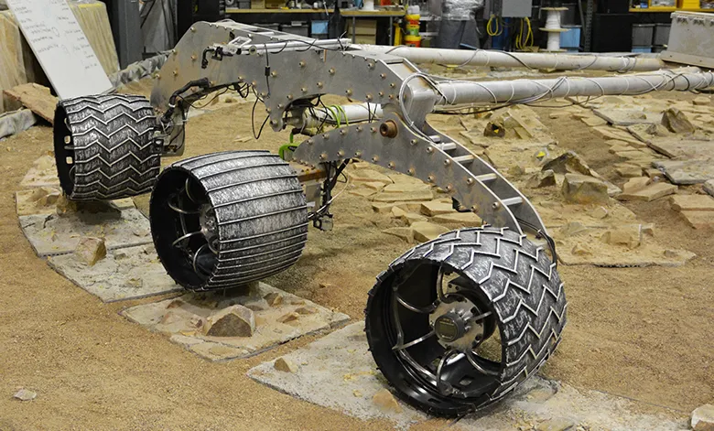

[**JPL Open Source Rover**](https://open-source-rover.readthedocs.io/en/latest/index.html)